1. I created a spreadsheet with some calculations for fan blade design. I will look more into softwares that generates a blade for us.
   1. Velocity triangle example:

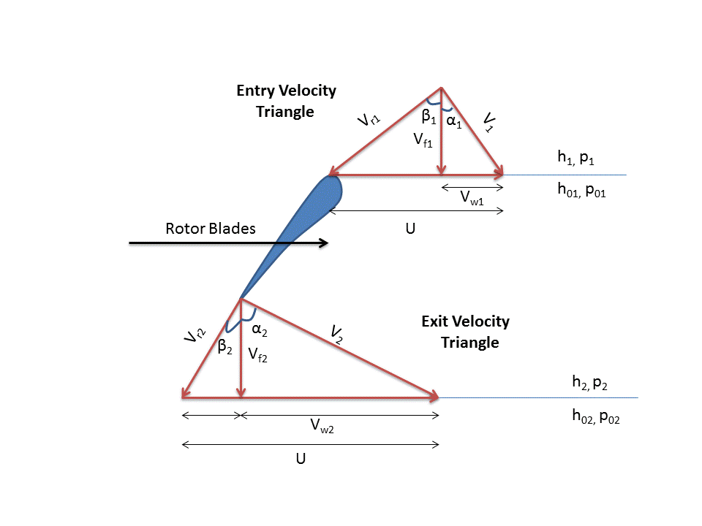

* 1. Yesterday night’s blade design (impeller)

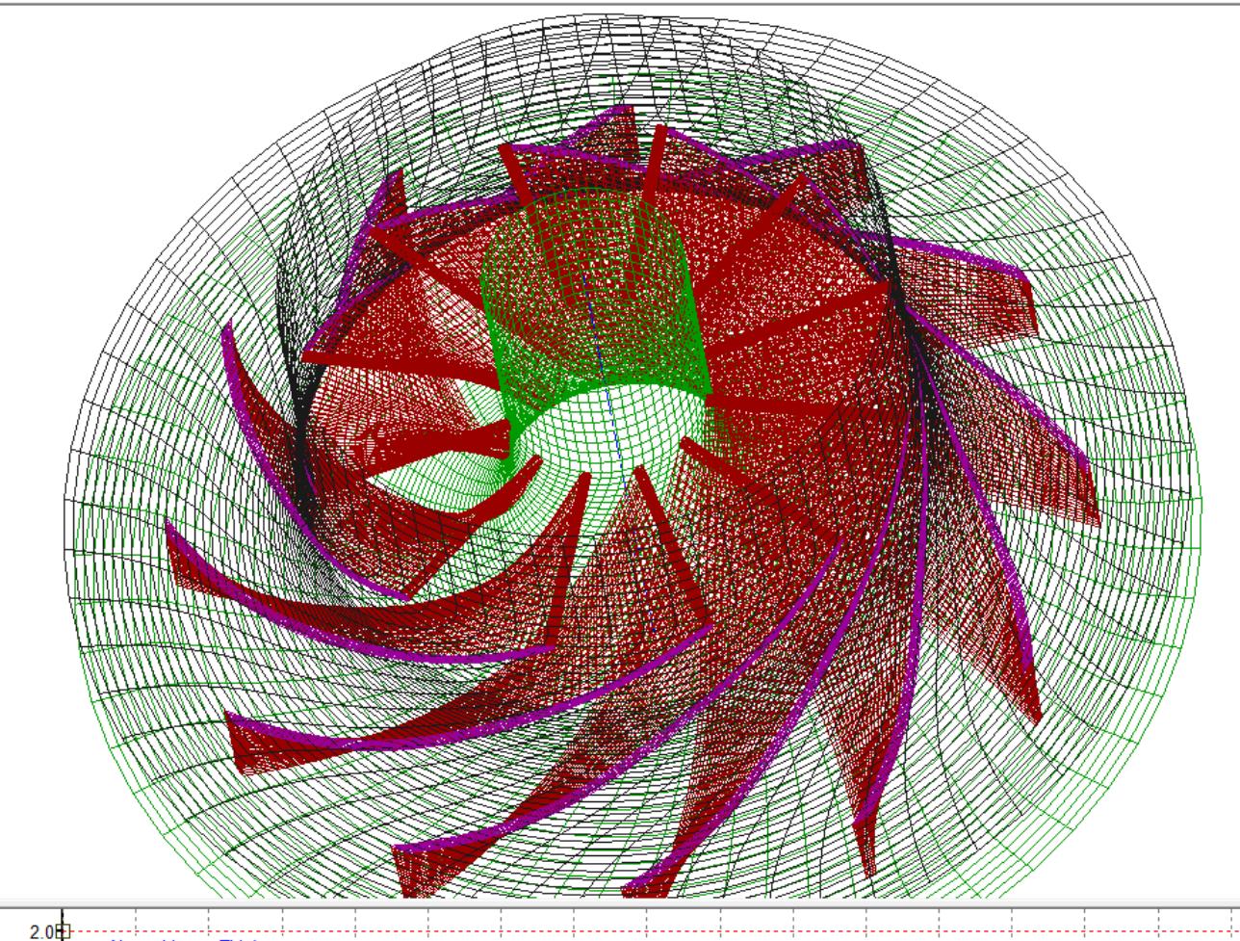

1. We should look into how to put letters on our part in Fusion 360. This is for putting ‘The University of Texas at Austin’

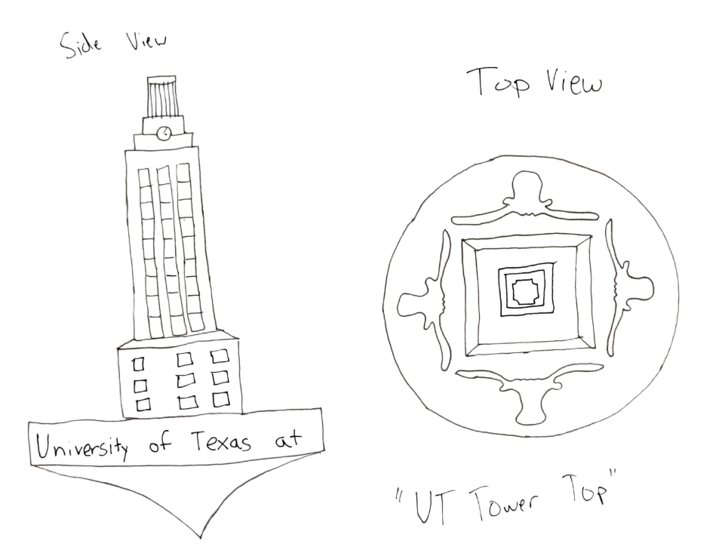

* 1. It seems like there is a similar feature, although not what we are looking for <https://www.autodesk.com/products/fusion-360/blog/quick-tip-engraving-cam/>
  2. SLS Design guideline lecture had test pieces with embedded and raised lettering. I’m sure there’s a way to incorporate letters easily

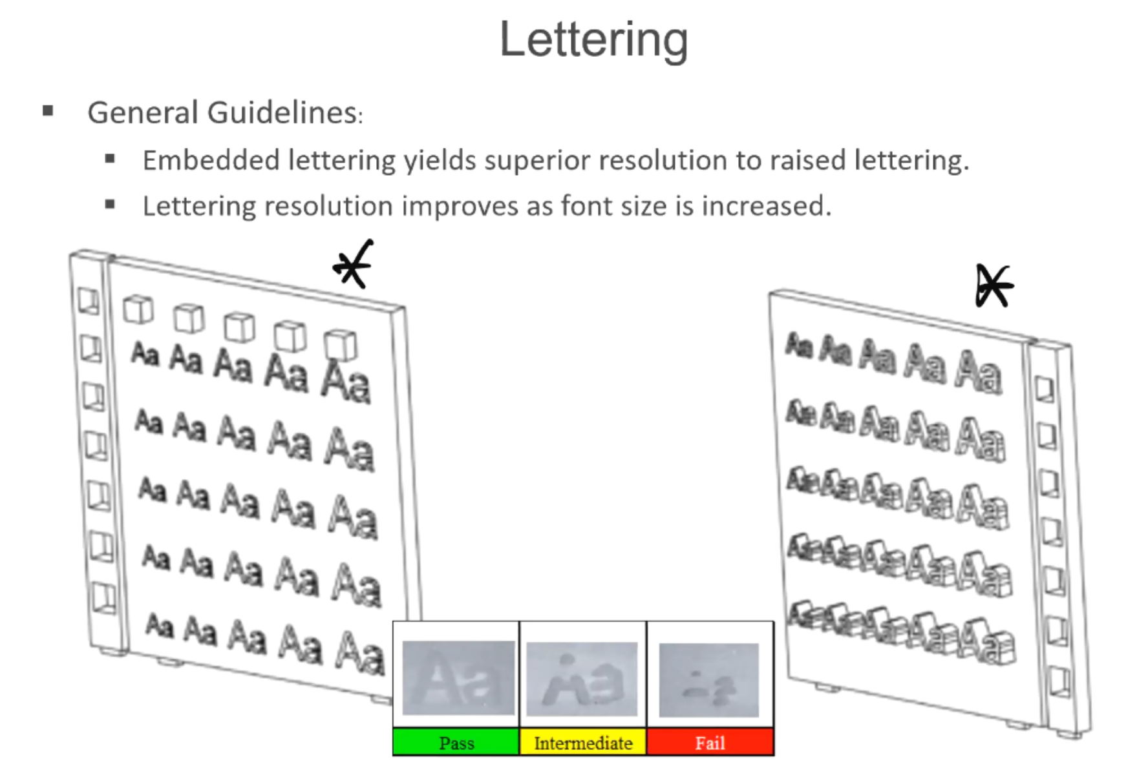

1. Start writing report

* Customer interview
* Finite element analysis?
* Adhering to design guidelines

1. Individual CAD work
   1. Fan design
   2. Aesthetics
      1. Letters
      2. Longhorn symbol
   3. Tower design
      1. Speaking of tower, are there any alternatives that represent UT? The tower doesn’t look great on a circular spinning top. The aerodynamics are a problem too: Some fans have wider inlet, some have narrower inlet.

